# TIINGO API CONFIG SETUP

Methodology

1. Install Kaggle CLI -pip install Kaggle

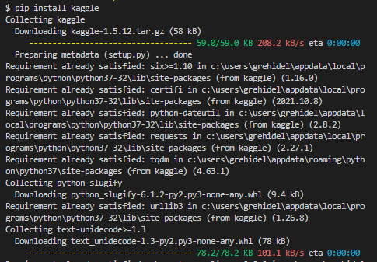

1. Determine the working directory

